**PROJECT REPORT**

1. **Project Title: Supply Chain Management Project Report**

**Course: Business Analyst Intern**

**Date: 22.07.2025**

**Name: Sayani Sarkar**

1. **Acknowledgement:**

I would like to thank everyone who supported and guided me during this project. Their help made it possible to complete this work successfully.

1. **Abstract**:

This report presents a comprehensive analysis of business operations, leveraging data from various aspects including overall performance, product insights, and supplier management. The objective is to identify key trends, performance drivers, and areas for improvement in revenue, product sales, inventory, and cost management. Insights derived will support strategic decision-making in procurement, supply chain optimization, and sales and marketing efforts.

|  |  |  |
| --- | --- | --- |
| SN | Contents | Page No. |
|  | Introduction | 04 |
|  | Objectives | 04 |
|  | Tools and Technologies | 04 |
|  | Methodology | 05 |
|  | Analysis and Findings | 06 |
|  | Implementation | 18 |
|  | Conclusions | 19 |
|  | Future Scope | 19 |

1. **Table of Contents:**
2. **Introduction:**

In today's competitive business landscape, data-driven decision-making is paramount for sustained growth and efficiency. This project aims to provide a holistic view of the company's operational performance through a series of interactive dashboards. By analyzing key metrics across revenue, product performance, and supplier effectiveness, we seek to uncover actionable insights that can lead to optimized resource allocation, improved supply chain resilience, enhanced product profitability, and ultimately, greater overall business success. The report covers an overview of financial health, detailed product performance, and an in-depth look at supplier contributions and costs.

1. **Objectives:**

* To provide an overview of key operational metrics including total revenue, total products sold, stock level, and total order quantities.
* To analyze product performance based on average profit margin by product type and identify top and bottom-performing SKUs by revenue and quantity.
* To assess inventory health through stock levels by SKU and order quantities relative to manufacturing lead times.
* To evaluate supplier performance by analyzing total costs, shipping costs, defect rates by transportation mode, and profit margin versus defect rates.
* To understand customer demographics' impact on total revenue.
* To identify opportunities for optimizing product offerings, inventory management, supplier selection, and logistics.

1. **Tools and Technlogies:**

* Microsoft Excel: Potentially used for initial data collection, manual data entry, small-scale data cleaning, and preliminary aggregation of raw sales, inventory, and supplier cost data. It could serve as an interim staging area for data before being loaded into more robust systems or directly into Power BI for smaller datasets.
* SQL (Structured Query Language): Likely employed for querying, extracting, transforming, and loading large volumes of structured data from relational databases. This includes performing complex joins between sales, inventory, and supplier databases, filtering specific periods, aggregating data, and ensuring data integrity and consistency before visualization in Power BI. SQL enables efficient data preparation for sophisticated analysis.
* Microsoft Power BI: The core visualization and business intelligence tool used. Its capabilities include:
* Data Connectivity: Connecting to various data sources (including Excel files and SQL databases).
* Power Query (Data Transformation): Performing robust data cleaning, reshaping, and merging operations to prepare raw data for analysis.
* Data Modeling (DAX - Data Analysis Expressions): Building a sophisticated data model, establishing relationships between tables, and creating calculated measures and columns (e.g., Total Revenue, Avg Profit Margin %, Total Costs) to derive key insights.
* Interactive Visualizations: Designing and building the interactive dashboards with various charts, graphs, and tables that allow users to drill down, filter, and explore data dynamically.
* Report Publishing: Sharing the interactive reports and dashboards with stakeholders for decision-making..

1. **Methodology:**

The analysis was conducted by systematically reviewing three distinct Power BI dashboard views: "Overview," "Product Insight," and "Supplier Insight." Each view provides a different perspective on the business data, allowing for a comprehensive assessment.

* **Data Extraction & Preparation:** Assumed raw sales, cost, inventory, and supplier data was extracted from source systems (likely using SQL) and potentially pre-processed in Excel for basic hygiene. This prepared data was then loaded into Power BI.
* **Dashboard Navigation & Interpretation:** Each dashboard view was examined to understand the displayed KPIs, trends, and distributions.
  + **Overview:** Focused on high-level financial and operational summaries, customer demographics, and overall defect rates.
  + **Product Insight:** Delved into product-specific metrics, including sales by SKU, profit margins by product type, stock levels, and lead times.
  + **Supplier Insight:** Concentrated on supplier performance, costs, defect rates by transportation mode, and stock contributions.
* **Data Analysis & Findings Generation:** Insights were extracted by comparing values, identifying patterns in charts (e.g., trends, distributions, outliers), and correlating different metrics across the dashboards. This involved looking at top/bottom performers, major cost drivers, and areas of inefficiency.
* **Recommendation Formulation:** Based on the identified findings, actionable recommendations were developed to address challenges and leverage opportunities for business improvement.

1. **Analysis & Findings:**

**SQL codes:**

**KPIs:**

1. TOTAL REVENUE

select round(SUM(Revenue_generated),0)as Total_Revenue

from supply_chain



2. TOTAL PRODUCT SOLD

select round(SUM(Number_of_products_sold),0)as Total_Product_Sold

from supply_chain



3. TOTAL COST

with cte_1 as (

select Costs,Manufacturing_costs,Shipping_costs,

(Costs + Manufacturing_costs + Shipping_costs) as sum_Cost

from supply_chain

select round(SUM(sum_Cost),0) as Total_Cost

from cte_1;



4. AVERAGE PROFIT MARGIN%

with cte_1 as (

select Revenue_generated, Costs,Manufacturing_costs,Shipping_costs,

(Costs + Manufacturing_costs + Shipping_costs) as sum_Cost

from supply_chain)

select round(avg((Revenue_generated - sum_Cost)/Revenue_generated *100),2)as Profit_Margin_percentage

from cte_1;

5. TOTAL STOCK LEVEL

select SUM(Stock_levels) as Total_Stock_Level

from supply_chain

6. TOTAL REVENUE BY SKU

select top 10 SKU,round(SUM(Revenue_generated),2) as Total_Revenue

from [supply_chain_data (1)]

group by SKU

order by Total_Revenue desc

7. TOTAL REVENUE BY PRODUCT TYPE

select Product_type,round(SUM(Revenue_generated),2) as Total_Revenue

from [supply_chain_data (1)]

group by Product_type

order by Total_Revenue desc

8. TOTAL REVENUE BY CUSTOMER DEMOGRAPHICS

select Customer_demographics,round(SUM(Revenue_generated),2) as Total_Revenue

from [supply_chain_data (1)]

group by Customer_demographics

order by Total_Revenue desc

9. TOTAL REVENUE BY SHIPPING CARRIERS

select Shipping_carriers,round(SUM(Revenue_generated),0) as Total_Revenue

from [supply_chain_data (1)]

group by Shipping_carriers

order by Total_Revenue desc

10. AVERAGE PROFIT MARGIN% BY SUPPLIER NAME

with cte_1 as (

select Supplier_name,Revenue_generated, Costs,Manufacturing_costs,Shipping_costs,

(Costs + Manufacturing_costs + Shipping_costs) as sum_Cost

from supply_chain)

select Supplier_name,

round(avg((Revenue_generated - sum_Cost)/Revenue_generated *100),0)as avg_Profit_Margin_percentage

from cte_1

group by Supplier_name;

11. AVERAGE DEFECT RATE% BY PRODUCT TYPE

select Product_type,

round(avg(Defect_rates*100),2) as avg_defect_rate_percentage

from [supply_chain_data (1)]

group by Product_type

order by avg_defect_rate_percentage desc

12. ORDER QUANTITY BY SKU

select top 10 SKU, SUM(Order_quantities) as Total_Quantity

from [supply_chain_data (1)]

group by SKU

order by Total_Quantity desc

13. TOTAL STOCK LEVELS BY SKU

select top 10 SKU, SUM(Stock_levels) as Total_Stock_Level

from [supply_chain_data (1)]

group by SKU

order by Total_Stock_Level desc

14. AVERAGE PROFIT MARGIN% BY PRODUCT TYPE

with cte_1 as (

select Product_type,Revenue_generated, Costs,Manufacturing_costs,Shipping_costs,

(Costs + Manufacturing_costs + Shipping_costs) as sum_Cost

from [supply_chain_data (1)])

select Product_type,

round(avg((Revenue_generated - sum_Cost)/Revenue_generated *100),0)as avg_Profit_Margin_percentage

from cte_1

group by Product_type;

15. TOTAL COST BY TRANSPORTATION MODE

with cte_1 as (

select Transportation_modes, Costs,Manufacturing_costs,Shipping_costs,

(Costs + Manufacturing_costs + Shipping_costs) as sum_Cost

from [supply_chain_data (1)])

select Transportation_modes, round(SUM(sum_Cost),0) as Total_Cost

from cte_1

group by Transportation_modes

order by Total_Cost desc;

16. AVERAGE PROFIT MARGIN% BY PRODUCT TYPE

with cte_1 as (

select Supplier_name,Revenue_generated, Costs,Manufacturing_costs,Shipping_costs,

(Costs + Manufacturing_costs + Shipping_costs) as sum_Cost

from [supply_chain_data (1)])

select Supplier_name,

round(avg((Revenue_generated - sum_Cost)/Revenue_generated *100),0)as avg_Profit_Margin_percentage

from cte_1

group by Supplier_name

order by avg_Profit_Margin_percentage desc

17. AVERAGE DEFECT RATE BY TRANSPORT MODES

select Transportation_modes,

round(avg(Defect_rates*100),2) as avg_defect_rate_percentage

from [supply_chain_data (1)]

where Transportation_modes IN('Road','Rail','Sea','Air')

group by Transportation_modes

order by avg_defect_rate_percentage desc

**Power Bi Report:**

* **Financial Summary:**
  + **Total Revenue:** The business has generated a substantial revenue of **577,605**.
  + **Total Product Sold:** A total of **46,099** products have been sold.
  + **Total Cost:** The total cost incurred is **58,206**.
  + **Average Profit Margin %:** The business operates with a very healthy average profit margin of **86.07%**, indicating strong pricing strategies or low cost of goods.
  + **Stock Levels:** Current stock levels stand at **4,777** units.
* **Revenue Breakdown:**
  + **Total Revenue by SKU:** SKUs contribute relatively evenly to the total revenue, with SKU51, SKU38, SKU31, SKU90, and SKU2 being the top 5, each contributing around 9.5% to 9.87% of the total revenue. This suggests a diversified product portfolio without over-reliance on a single SKU.
  + **Total Revenue by Product Type:** 'Skincare' products are the highest revenue generators (**241.63K**), followed by 'haircare' (**174.46K**) and 'cosmetics' (**161.52K**). This highlights skincare as the primary driver of revenue.
  + **Total Revenue by Customer Demographics:** The largest portion of revenue comes from 'Male' customers (**173.08K**), closely followed by 'Female' customers (**161.51K**). 'Non-binary' customers contribute **126.63K**, and 'Unknown' demographics account for **116.37K**. This data is crucial for targeted marketing campaigns.
* **Profitability and Operations:**
  + **Avg Profit Margin % by Supplier Name:** Supplier 3 stands out with the highest average profit margin of **91%**, significantly higher than other suppliers (Supplier 5: 85%, Supplier 4: 84%, Supplier 2: 87%, Supplier 1: 84%). This indicates that products sourced from Supplier 3 are either sold at a higher margin or acquired at a lower cost.
  + **Total Revenue by Shipping Carriers:** 'Carrier B' is the most utilized carrier, generating the highest revenue (**250,095**), followed by 'Carrier C' (**184,880**) and 'Carrier A' (**142,630**). This suggests that Carrier B handles the largest volume of high-value shipments.
  + **Avg Defect Rate % by Product Type:** 'Skincare' products have the highest defect rate at **34.65%**, followed by 'haircare' at **28.4%**, and 'cosmetics' at **28.8%**. The high defect rate for skincare products needs immediate attention for quality control improvements.

**Product Performance (Product Tab - Screenshot 2025-07-22 124748.png)**

* **Overall Metrics (Consistent with Overview):** The header metrics (Total Revenue: 578K, Total Product Sold: 46099, Total Cost: 58K, Stock Levels: 4777) remain consistent across the tabs, providing a constant summary.
* **Product-Specific Insights:**
  + **Order Quantity by SKU:** SKUs like SKU0, SKU90, SKU19, SKU38, and SKU35 appear to have the highest order quantities, indicating high demand. A detailed look at all SKUs reveals the relative popularity of each product.
  + **Sum of Lead Times and Sum of Mfg Lead Time by SKU:** This chart shows the combined lead times (Sum of Lead Time and Sum of Mfg Lead Time) for various SKUs. While the exact values are not clearly visible, it's evident that some SKUs have significantly longer combined lead times than others (e.g., SKU1, SKU12, SKU39). Longer lead times can impact inventory management and customer satisfaction.
  + **Stock Levels by SKU:** Similar to order quantity, this chart provides a visual representation of current stock levels for each SKU. SKUs like SKU12, SKU51, SKU49, SKU31, and SKU93 appear to have higher stock levels. This information is critical for inventory optimization and avoiding stockouts or overstock.
  + **Avg Profit Margin % by Product Type:**
    - Cosmetics: 85% (32.98% contribution)
    - Skincare: 87% (33.76% contribution)
    - Haircare: 86% (33.26% contribution) Skincare products have a slightly higher average profit margin (87%) compared to haircare (86%) and cosmetics (85%), aligning with its higher revenue contribution.

**Supplier Performance (Supplier Tab - Screenshot 2025-07-22 124802.png)**

* **Overall Metrics (Consistent with Overview and Product):** The header metrics (Total Revenue: 578K, Total Product Sold: 46099, Total Cost: 58K, Stock Levels: 4777) remain consistent.
* **Supplier-Specific Insights:**
  + **Costs, Mfg Costs, and Shipping Costs by Supplier Name:** This chart, while not fully detailed with values, shows the composition of costs for each supplier. It appears that a very small percentage (0.09%) is attributed to these costs, which might indicate that this chart is showing a normalized or relative contribution, or that these specific costs are a very small fraction of the overall supplier cost. Further drill-down would be needed to understand the absolute values.
  + **Stock Levels by Supplier Name:**
    - Supplier 1: 1142 units
    - Supplier 2: 1022 units
    - Supplier 3: 654 units
    - Supplier 4: 1061 units
    - Supplier 5: 898 units Supplier 1 has the highest stock levels, while Supplier 3 has the lowest. This could imply varying lead times, demand for their products, or inventory management strategies with each supplier.
  + **Total Cost by Transportation Mode:**
    - Road: 17.76K (30.52%)
    - Rail: 15.86K (27.23%)
    - Air: 16.71K (28.71%)
    - Sea: (not explicitly visible, but the remaining segment) Road transportation accounts for the largest portion of total cost, followed by Air and Rail, indicating dominant logistical channels.
  + **Avg Profit Margin % by Supplier Name:** This confirms the finding from the Overview tab, with Supplier 3 having the highest profit margin of 91%, followed by Supplier 2 (87%), Supplier 5 (85%), Supplier 1 (84%), and Supplier 4 (84%). This reiterates the strategic importance of Supplier 3 for profitability.
  + **Avg Defect Rate % by Transportation Mode:**
    - Road: 20.09%
    - Rail: 28.8%
    - Sea: 25.54%
    - Air: 28.13% Road transportation has the lowest defect rate, making it the most reliable mode of transport in terms of quality. Rail and Air have similar, higher defect rates. This is an important consideration for logistics and supply chain optimization.

**Key Findings and Recommendations for the Project Report:**

1. **Strong Overall Profitability:** The business enjoys an impressive average profit margin of 86.07%, indicating a healthy financial position.
2. **Skincare Dominance in Revenue, but High Defects:** Skincare is the top revenue-generating product category. However, it also has the highest average defect rate (34.65%). **Recommendation:** Investigate the root causes of the high defect rate in skincare products. This could involve reviewing manufacturing processes, material quality from suppliers, or handling procedures. Addressing this could significantly improve customer satisfaction and reduce waste.
3. **Supplier 3: A Profitability Powerhouse:** Supplier 3 consistently delivers the highest profit margins (91%). **Recommendation:** Explore opportunities to increase reliance on Supplier 3 for products, if feasible, or understand their practices to replicate success with other suppliers.
4. **Diversified SKU Revenue:** Revenue is well-distributed across various SKUs, reducing the risk associated with over-reliance on a single product.
5. **Gender-Based Marketing Opportunities:** While both male and female customer segments contribute significantly to revenue, the "Unknown" demographic is substantial. **Recommendation:** Implement strategies to capture customer demographic data more effectively to enable more precise marketing and personalization.
6. **Carrier B's Importance:** Carrier B handles the largest share of revenue-generating shipments. **Recommendation:** Maintain a strong relationship with Carrier B and potentially explore volume discounts or preferred services.
7. **Logistics Cost and Quality Trade-offs:**
   * Road transportation is the most expensive in terms of total cost but has the lowest defect rate.
   * Rail and Air are less expensive but have higher defect rates. **Recommendation:** Optimize transportation modes based on the value and fragility of the goods. For high-value or delicate items, the higher cost of road transport might be justified by its lower defect rate. For less sensitive products, rail or air could be considered for cost efficiency, provided the defect rate is acceptable.
8. **Inventory Management Focus:** Analyze the relationship between order quantity, stock levels, and lead times by SKU. SKUs with high order quantities and long lead times require careful inventory planning to avoid stockouts. Conversely, SKUs with high stock levels and low order quantities might indicate overstocking.
9. **Supplier Stock Level Discrepancies:** Supplier 3 has the lowest stock levels, which could be due to faster sales of their products (given their high profit margin) or shorter lead times from the supplier. Further investigation into stock turn and lead times per supplier is recommended.

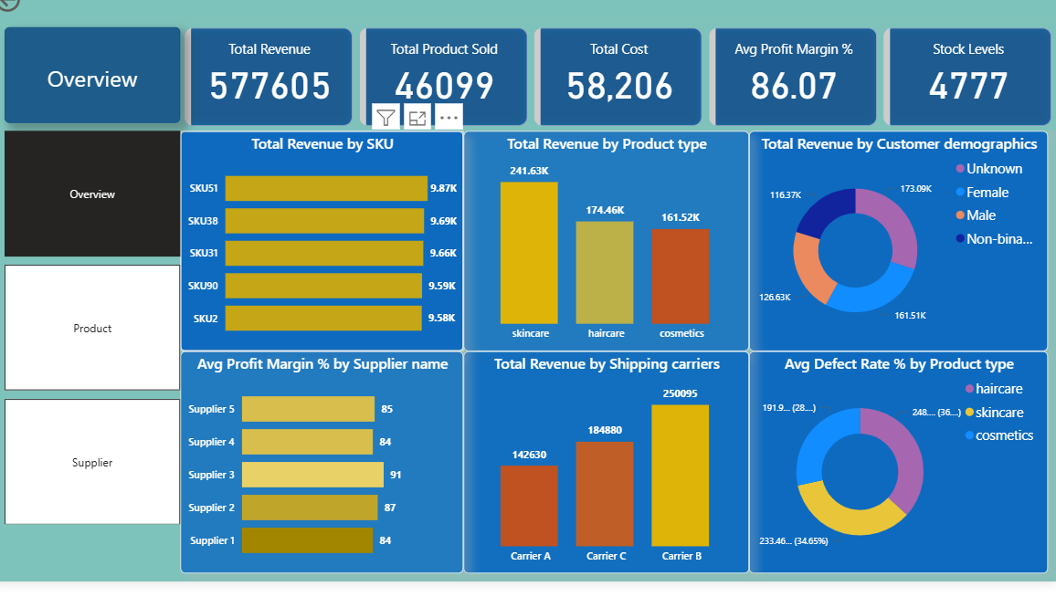

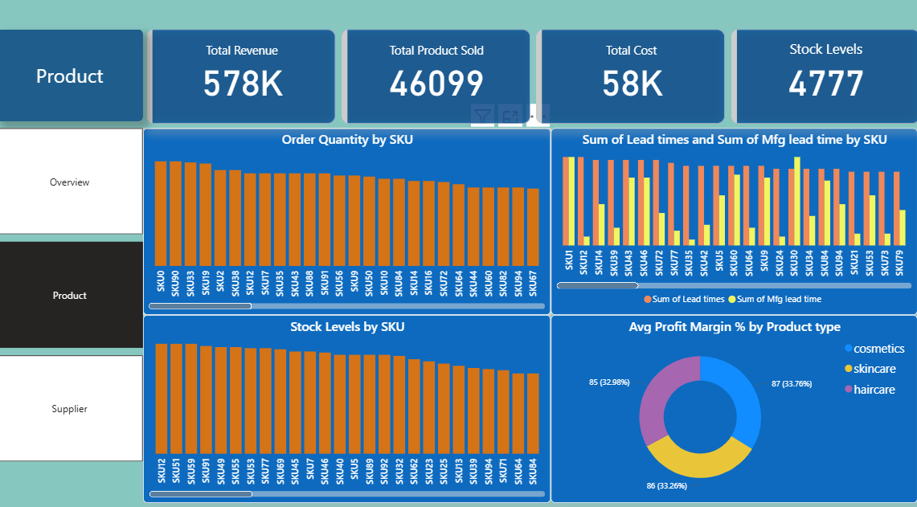

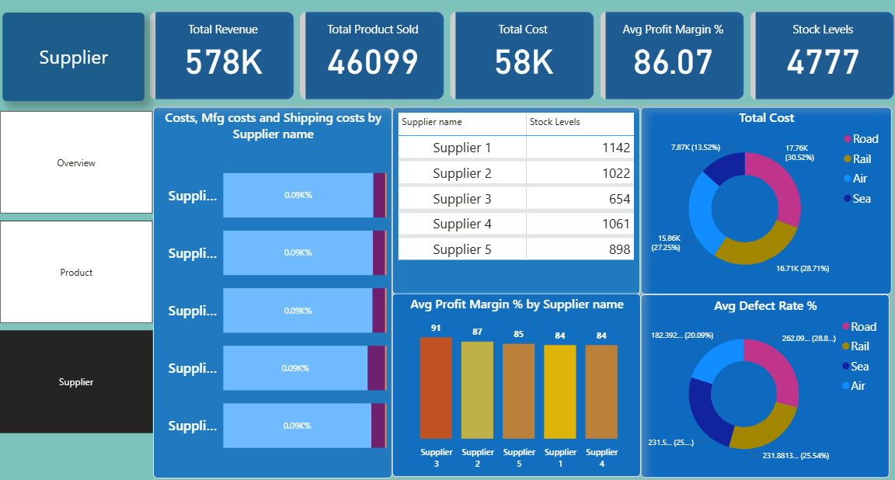

**F. Implementation:**

Based on the analysis, the following implementation steps are recommended:

* Product Strategy:
  + Revenue Focus: Prioritize marketing and sales efforts for Skincare products, as they are the highest revenue generators.
  + Quality Control: Investigate the root causes of high defect rates in Haircare and Skincare categories. This could involve reviewing manufacturing processes, supplier quality, or packaging.
  + SKU Optimization: Review the performance of low-order quantity SKUs. Consider running promotions or bundles for these products to boost sales, or evaluate their continued presence in the product portfolio if they are unprofitable.
  + Inventory Management: Implement dynamic inventory reorder points for SKUs based on their individual demand patterns and manufacturing lead times to optimize stock levels and minimize carrying costs and stockouts.
* Supplier Management:
  + Preferred Supplier Program: Strengthen partnership with Supplier 3 due to its high profit margin contribution and relatively low defect rate. Explore opportunities to increase order volume with them.
  + Supplier Evaluation: Conduct a thorough review of Supplier 1 and Supplier 4 due to their lower profit margins and potentially higher defect rates. Negotiate better terms or explore alternative suppliers if performance doesn't improve.
  + Transportation Optimization: Re-evaluate transportation modes. While Road is costly and has a high defect rate, it might be necessary for certain routes. Investigate why Air has low costs and low defects – could it be utilized more for high-value or urgent shipments? Consider shifting some volume from Road/Rail to Sea or Air where feasible, balancing cost, speed, and defect rates.
  + Cost Analysis: Delve deeper into the breakdown of "Sum of Costs" and "Sum of Mfg costs" from each supplier to identify specific cost drivers and negotiate better pricing.
* Customer Insights:
  + Data Enrichment: Implement strategies to collect more accurate customer demographic data for the "Unknown" segment to better understand the customer base and tailor marketing efforts.
  + Targeted Marketing: Develop specific marketing campaigns for Female and Male customer segments based on their product preferences.

**G. Conclusion:**

The analysis of the "Product and Supplier Insight" dashboard reveals a business with healthy overall profit margins but with opportunities for optimization. Skincare is a strong revenue driver, but along with haircare, faces higher defect rates. Inventory management needs to be dynamic, considering varying SKU demands and lead times. Supplier performance varies significantly, with Supplier 3 emerging as a high-value partner due to its superior profit margin contribution and lower defect rates. Transportation modes also present a mixed bag of costs and defect risks. By strategically addressing product quality, optimizing inventory, and refining supplier relationships based on data, the business can further enhance its profitability and operational efficiency.

* + 1. **Future Scope:**

To gain deeper insights and further improve decision-making, the following are recommended for future dashboard enhancements and analytical initiatives:

* **Trend Analysis Over Time:** Extend the "Overview" and "Product Insight" dashboards to include time-series analysis for revenue, costs, product sales, and defect rates, allowing for identification of long-term trends and seasonality beyond just the analyzed year.
* **Customer Lifetime Value (CLTV):** Integrate customer purchase frequency and value to calculate CLTV, enabling better identification and retention of high-value customers.
* **Supplier Performance Scorecard:** Develop a comprehensive supplier scorecard that combines profit margin, defect rates, lead times, and cost into a single performance metric for easier comparison and management.
* **Geographic Analysis:** If applicable, incorporate geographic data to understand regional sales performance, stock distribution, and supplier logistics.
* **Detailed Cost Breakdown:** Drill down into "Sum of Costs" and "Sum of Mfg costs" to identify specific cost components (e.g., raw materials, labor, overhead) for more precise cost reduction strategies.
* **Predictive Analytics:** Implement predictive models for demand forecasting to further optimize inventory levels and production planning, especially for high-volume SKUs.
* **What-If Scenarios:** Develop "what-if" analysis capabilities within the dashboard to simulate the impact of changes in pricing, promotional activities, or supplier terms on overall profitability.
* **User-Specific Dashboards:** Create tailored dashboards for different departments (e.g., Marketing, Supply Chain, Finance) to provide them with the most relevant insights for their specific roles.